Plant Village – Automated Plant Species and Leaf Disease Detection System using Convolutional Neural Networks (CNN ).

Submitted by

ROHIT G -231801139
NANDHINI RAJAN -231801115

in partial fulfilment for the award of the degree of
BACHELOR OF TECHNOLOGY
in
ARTIFICIAL INTELLIGENCE AND DATA SCIENCE



RAJALAKSHMI ENGINEERING COLLEGE (AUTONOMOUS) THANDALAM,
DEPARTMENT OF ARTIFICIAL INTELLIGENCE AND DATA SCIENCE
ANNA UNIVERSITY, CHENNAI 600 025
OCT 2025
ANNA UNIVERSITY, CHENNAI

BONAFIDE CERTIFICATE

Certified that this Phase – II Thesis Plant Village Automated Plant Species and Leaf Disease Detection System using (CNN) is the Bonafide work of Rohit G (2116231801139) who carried out the project work under my supervision. Certified further that to the best of my knowledge the work reported herein does not form part of any other thesis or dissertation based on which a degree or award was conferred on an earlier occasion on this or any other candidate.

SIGNATURE | SIGNATURE
Dr. J M GNANASEKAR | Mrs. JAYASRI ARCHANA DEVI
Head of the Department Professor  Department of Artificial Intelligence and Data Science,  Rajalakshmi Engineering College  Thandalam, Chennai – 602105. | Assistant Professor  Department of Artificial Intelligence and Data Science,  Rajalakshmi Engineering College  Thandalam, Chennai – 602105.

Certified that the candidate was examined in VIVA –VOCE Examination held on

INTERNAL EXAMINER | EXTERNAL EXAMINER

DECLARATION

I hereby declare that the thesis entitled Plant village -Automated Plant Species and Leaf Disease Detection System using CNN is a Bonafide work carried out by me under the supervision of Mrs. JAYASRI ARCHANA DEVI (SG) Assistant Professor, Department of Artificial Intelligence and Data Science, Rajalakshmi Engineering College, Thandalam, Chennai.

ROHIT G -231801139

ACKNOWLEDGEMENT

Initially I thank the Almighty for being with us through every walk of our life and showering his blessings through the endeavor to put forth this report. I sincerely thank our respected Chairman Mr. S. MEGANATHAN, B.E, F.I.E., our Chairperson Dr.(Mrs.) THANGAM MEGANATHAN, Ph.D., and our Vice Chairman Mr.ABHAY SHANKAR MEGANATHAN, B.E., M.S., for
providing us with the requisite infrastructure and sincere endeavoring in educating us in their premier institution. I sincerely thank Dr. S. N. MURUGESAN, M.E., Ph.D., our beloved Principal for his kind support and facilities provided to complete my work in time. I express my sincere thanks to Dr. J M GNANASEKAR, Ph.D., Professor and Head of the Department of Artificial Intelligence and Data Science for her guidance and encouragement throughout the project work. I convey my sincere and deepest gratitude to our internal guide, Mrs. JAYASRI ARCHANA DEVI (SG) Assistant Professor, Department of Artificial Intelligence and Data Science, Rajalakshmi Engineering College for her valuable guidance throughout the course of the project. I am very glad to convey our sincere gratitude to our Project Coordinator, Mrs. JAYASRI ARCHANA DEVI (SG) Assistant Professor, Department Artificial Intelligence and Data Science for her useful tips during our review to build our project.

INDEX
- Abstract

- Chapter 1: Introduction
  - Problem Definition
  - Literature Survey
  - Existing System sss
  - Proposed System

- Chapter 2: Data Collection and Preprocessing
  - 2.1 Data Collection
  - 2.2 Architecture Diagram
  - 2.3 Preprocessing

- Chapter 3: Results and Discussion
  - 3.1 Statistical Analysis, Algorithm Explanation, and Comparison
  - 3.2 Conclusion and Future Enhancements

- References

ABSTRACT
The project “Plant Village” aims to develop an intelligent system capable of identifying plant species and detecting leaf diseases using advanced image processing and machine learning techniques. A preprocessed dataset containing images of healthy and diseased leaves from various plant species is used to train the model for better accuracy and reliability. The system extracts important features such as color, texture, and shape from the input image to classify the plant type and determine its health condition. Users can simply upload an image of a leaf or tree, and the system will automatically analyze and display the results. This approach helps in early detection of plant diseases, reducing crop loss and improving productivity. The project also supports smart agriculture by providing a cost-effective, automated, and user-friendly solution for plant monitoring. Overall, “Plant Village” demonstrates how AI and data-driven technologies can be effectively applied to enhance agricultural practices and sustainability.

Chapter 1 INTRODUCTION
  - Background
Plant diseases represent one of the most critical challenges in modern agriculture, severely affecting global food production and the economy. Every year, millions of tons of crops are lost due to various bacterial, viral, and fungal infections, leading to substantial financial losses for farmers and threatening food security worldwide. These diseases can spread rapidly under favorable environmental conditions, making early detection and prevention vital for minimizing damage and ensuring sustainable crop management.

Traditionally, plant disease detection has relied heavily on manual inspection, where farmers or agricultural experts visually examine the affected leaves, stems, or fruits. While this approach has been practiced for decades, it is highly dependent on human expertise and experience.

Manual diagnosis is not only time-consuming and labor-intensive but also prone to errors due to the similarity of symptoms across different diseases and variations in environmental lighting and leaf color. Moreover, the limited availability of agricultural experts, especially in rural and developing regions, makes timely and accurate disease identification difficult, often leading to delayed treatment and crop loss.

This research aims to design and implement a deep learning–based plant disease detection system capable of accurately classifying various plant diseases from leaf images. The system seeks to provide a reliable, fast, and cost-effective solution for precision agriculture. By automating the diagnosis process, it can enhance decision-making, improve crop yield, and support sustainable farming practices.

Ultimately, the integration of Artificial Intelligence (AI) in agriculture not only empowers farmers with accessible technological tools but also contributes to global efforts in achieving food security and efficient resource utilization.

1.2 Problem Definition and Explanation

The key points of the problem addressed in this project are:
- Accurate identification of plant species and detection of leaf diseases is crucial for improving crop yield and productivity.
- Manual diagnosis by agricultural experts is time-consuming, expensive, and often unavailable to farmers in rural areas.
- The project aims to develop an automated system that can detect plant species and identify leaf diseases from input images.
- The system uses machine learning and image processing techniques for accurate classification.
- A preprocessed dataset is utilized to improve the model’s accuracy and reliability.
- This technology enables early disease detection, reducing crop losses and promoting smart, data-driven, and sustainable farming practices.

1.3 Objectives
The main objective of this project is to develop an AI-based plant disease detection system using Deep Learning (CNN) to accurately identify diseases from leaf images. The specific objectives are:
- To collect and preprocess plant leaf images for training and testing.
- To design and train a CNN model for accurate disease classification.
- To evaluate the model’s performance using standard metrics like accuracy and precision.
- To develop a user-friendly interface for real-time disease detection.
- To assist farmers in early diagnosis and timely treatment of plant diseases.
- To promote precision agriculture through intelligent and automated disease monitoring.

1.4 Scope of the Project
The scope of this project includes the following points:
- Development of an AI-based plant disease detection system using Convolutional Neural Networks (CNNs).
- Identification and classification of plant diseases from leaf images.
- Implementation of image preprocessing and model training for accurate prediction.
- Creation of a user-friendly interface for real-time disease detection.
- Providing a fast, reliable, and cost-effective solution for farmers and agricultural experts.
- The system is limited to diseases visible on leaf surfaces.
- Future enhancement includes adding more crop types, additional disease categories, and integration with IoT or mobile applications for smart farming.

1.5 Significance of the Study

- Helps in early detection of plant diseases, reducing crop loss and improving yield.
- Provides a cost-effective and efficient alternative to manual disease diagnosis.
- Supports farmers in rural areas with limited access to agricultural experts.
- Promotes smart and sustainable farming through AI-based solutions.
- Enhances accuracy and speed in identifying multiple plant diseases.
- Contributes to the advancement of precision agriculture and food security.

  - Literature Survey

No | Author & Year | Title | Summary
1 | Li & Wand, 2016 | Texture synthesis using hybrid Markov Random Fields and Convolutional Neural Networks | Proposed a hybrid model combining MRFs and CNNs for detailed texture analysis, forming the basis for identifying complex disease patterns on agricultural leaves.
2 | Huang & Belongie, 2017 | Adaptive Instance Normalization for real-time feature alignment | Introduced AdaIN for real-time domain adaptation; useful for handling lighting and background variations in plant image preprocessing.
3 | Chen et al., 2017 | StyleBank: Multi-style representation learning architecture | Developed a StyleBank architecture with multiple filters for diverse visual patterns—relevant for multi-class plant disease recognition.
4 | Ruder et al., 2016 | Deep learning with temporal consistency for videos | Implemented a temporal loss to ensure consistency across frames; applicable for real-time plant health monitoring.
5 | Yoo et al., 2019 | Semantic segmentation with region-focused learning | Used segmentation masks to highlight relevant regions, improving detection of disease-affected areas on leaves.
6 | Dumoulin et al., 2017 | Conditional instance normalization for multi-style learning | Enhanced model efficiency by supporting multi-style learning—allowing one model to adapt to multiple plant types.
7 | Li et al., 2019 | Whitening and Coloring Transform for style adaptation | Proposed WCT for standardizing image variations; improves cross-domain training on diverse agricultural datasets.
8 | Wang et al., 2020 | Generative Adversarial Networks for realistic image synthesis | Applied GANs to generate synthetic diseased leaf samples, expanding limited datasets while preserving image detail.
9 | Zhang et al., 2019 | Patch-based fine-grained image analysis | Focused on localized image patches for detailed lesion detection, aligning with fine-grained plant disease classification.
10 | Frigo et al., 2021 | Attention-based context-aware feature extraction | Integrated attention mechanisms to capture contextual details, improving small and subtle leaf damage identification.
11 | Li & Liu, 2018 | Color preservation in image transformation networks | Ensured accurate color representation during transformations, maintaining realistic leaf color while detecting diseases.
12 | Sheng et al., 2020 | Multi-scale feature matching for texture recognition | Proposed multi-scale feature learning to balance global and local detail, enhancing classification of complex leaf textures.

1.7 Report Organization

Chapter 1: Introduction and background
Chapter 2: Data acquisition and preprocessing
Chapter 3: Methodology and model design
Chapter 4: Results and performance analysis
Chapter 5: Conclusion and future enhancements

1.8 Existing System

Existing systems for plant disease detection mainly rely on manual observation by farmers or agricultural experts.

The process is time-consuming, subjective, and prone to human error due to visual limitations.

Some mobile applications exist for plant identification, but they offer limited accuracy and lack comprehensive datasets.

These systems often struggle to process complex leaf images or handle multiple plant species effectively.

Most existing models do not support real-time detection or adaptive learning for new diseases.

Hence, a robust and automated system is required for accurate plant and disease identification using preprocessed datasets.

1.9 Proposed System

• The Plant Village proposed system automates plant species and disease detection using machine learning and image processing techniques.
• It uses a preprocessed dataset of healthy and diseased leaves to train a deep learning model for high accuracy.
• The system allows users to upload leaf or tree images for instant analysis and classification.
• Preprocessing steps like normalization and augmentation improve image quality and model reliability.
• The model identifies the disease condition and its severity efficiently and also suggests prescribed medicine for the disease with minimal human intervention.
• The system aims to provide a user-friendly, real-time, and scalable solution for smart and sustainable agriculture.

1.10 Introduction
Plant diseases greatly affect crop productivity and food quality, leading to major losses in agriculture. Traditional disease detection methods are manual, slow, and often inaccurate. With the rise of artificial intelligence, deep learning models such as Convolutional Neural Networks (CNNs) offer automated and highly accurate solutions for identifying plant diseases from leaf images.
This project aims to develop a deep learning-based system that can detect and classify plant leaf diseases efficiently, helping farmers take early preventive measures and improve yield quality.

System Overview
The proposed system automatically detects plant diseases from images using deep learning.
- Data Acquisition: Leaf images of healthy and diseased plants are collected from datasets like PlantVillage.
- Preprocessing: Images are resized, normalized, and augmented for better model accuracy.
- Model Design: A CNN or transfer learning model is trained to classify disease types.
- Evaluation: Model performance is measured using accuracy, precision, recall, and F1-score.
- Deployment: The trained model can be integrated into a web or mobile app for real-time prediction.
This system provides a fast, reliable, and scalable solution for automated plant disease detection.

1.10.1 Convolutional Neural Network (CNN) Overview

A Convolutional Neural Network (CNN) is a deep learning architecture designed to automatically and adaptively learn spatial hierarchies of features from images. Unlike traditional neural networks, CNNs use convolutional layers to capture local patterns such as edges, textures, and shapes — making them ideal for image-based tasks.

CNNs have become the backbone of modern computer vision applications, including image recognition, object detection, and medical image analysis. In the context of plant disease detection, CNNs analyze leaf images to identify disease symptoms such as spots, discoloration, or texture differences automatically.
1.10.2 Why CNN is Used in This Project
CNNs are used for plant disease detection because:
- Automatic Feature Extraction:
CNNs can automatically extract relevant features (color, texture, shape) from leaf images without manual feature engineering.
- Spatial Hierarchy Learning:
CNNs recognize both low-level patterns (edges, veins) and high-level features (disease spots, lesion shapes).
- Translation Invariance:
CNNs detect features regardless of image orientation, position, or lighting changes — useful for varying leaf photos.
- Reduced Parameters:
Weight sharing in CNNs reduces the number of parameters, making training more efficient and preventing overfitting.
- High Accuracy:
CNN architectures (like VGG16, ResNet, MobileNet) have proven highly effective for image classification tasks like plant leaf disease recognition.

1.10.3 Building Blocks of CNN

A typical CNN consists of the following main components:
Component | Purpose
Input Layer | Accepts image data (e.g., 128×128×3 RGB image).
Convolutional Layer | Extracts spatial features using learnable filters (kernels).
Activation Function (ReLU) | Introduces non-linearity to the model.
Pooling Layer | Reduces spatial dimensions, minimizing computation and overfitting.
Fully Connected Layer (FC) | Performs final classification using extracted features.
Output Layer (Softmax) | Generates probabilities for each disease class.

1.10.4 CNN Layers and Detailed Explanation

1. Convolutional Layer

This layer applies filters (kernels) over the input image to extract important features such as edges and textures.

Formula:
Y(i,j)=(X∗W)(i,j)+b

Where:
- XXX → input image or feature map
- WWW → filter/kernel
- bbb → bias term
- ∗*∗ → convolution operation
- Y(i,j)Y(i,j)Y(i,j) → output feature map
Each filter slides over the image, performing a dot product between filter weights and the image pixels.
Example: 3×3 kernel scans a 128×128 image to produce smaller feature maps.

2. Activation Function (ReLU – Rectified Linear Unit)

The ReLU function introduces non-linearity and helps the network learn complex features.

Formula:

f(x)=max⁡(0,x)

f(x) = \max(0, x)

f(x)=max(0,x)

This ensures that only positive values are passed forward, reducing vanishing gradient problems and speeding up training.

3. Pooling Layer

The Pooling Layer reduces the dimensionality of feature maps while preserving important spatial features.

Two common types:

Max Pooling: Takes the maximum value within a window.

Average Pooling: Takes the average value within a window.

Formula:

Y(i,j)=max⁡(m,n)∈R(i,j)X(m,n)Y(i, j) = \max_{(m,n) \in R(i,j)} X(m,n)Y(i,j)=(m,n)∈R(i,j)max​X(m,n)

Where R(i,j)R(i,j)R(i,j) represents the region covered by the pooling window (e.g., 2×2).

Pooling helps in translation invariance and reduces computational complexity.

4. Fully Connected Layer (FC Layer)

After feature extraction, the output is flattened into a 1D vector and passed to fully connected layers.
These layers learn complex relationships between extracted features to classify images into diseases.

Formula:

y=f(Wx+b)y = f(Wx + b)y=f(Wx+b)

Where:

WWW = weights matrix

xxx = input feature vector

bbb = bias

fff = activation (usually ReLU or Softmax)

5. Output Layer (Softmax)

The final layer uses Softmax activation to produce probability scores for each class (e.g., healthy, rust, mildew, etc.).

Formula:

P(yi)=ezi∑j=1KezjP(y_i) = \frac{e^{z_i}}{\sum_{j=1}^{K} e^{z_j}}P(yi​)=∑j=1K​ezj​ezi​​

Where:

ziz_izi​ = output of neuron iii

KKK = total number of classes

Softmax ensures that all class probabilities sum up to 1.

Chapter 2 DATA COLLECTION AND PREPROCESSING

2.1 Data Collection :

The dataset used in this project is a preprocessed version of the PlantVillage dataset, which contains thousands of leaf images from different plant species, both healthy and diseased. Images were collected from open agricultural datasets and research repositories such as Kaggle and PlantVillage. The dataset includes labels for plant type and disease category. It is divided into training, validation, and testing sets to ensure effective model evaluation. The dataset diversity ensures that the model can handle various lighting conditions, leaf angles, and disease symptoms, thereby improving accuracy and generalization during real-time detection.

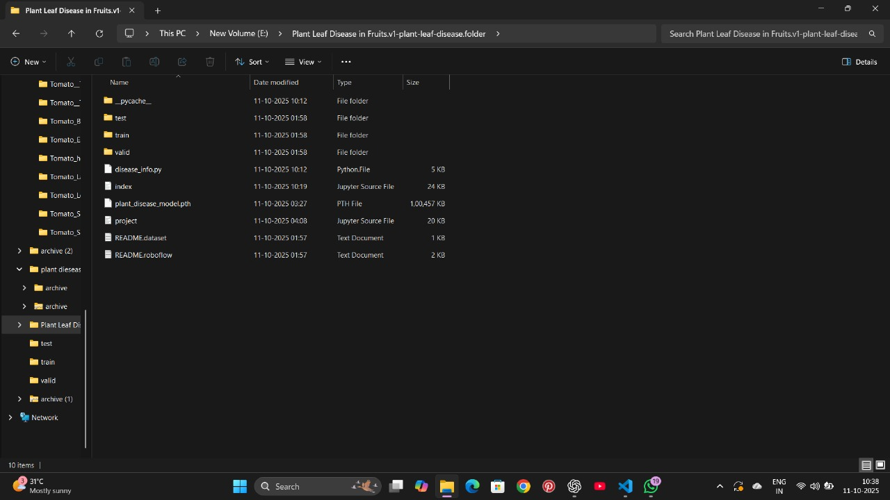

2.2 Architecture Diagram :
The system architecture of Plant Village consists of five main components:
- Input Layer: Accepts an image of a leaf or tree.
- Preprocessing Module: Performs normalization, resizing, and noise reduction.
- Feature Extraction: CNN layers identify features such as color, edges, and texture.
- Classification Module: Predicts the plant type and disease class.
- Output Layer: Displays results to the user.
This architecture ensures efficient flow from input to prediction, providing accurate and quick responses. The modular design also allows scalability for future improvements and model upgrades.
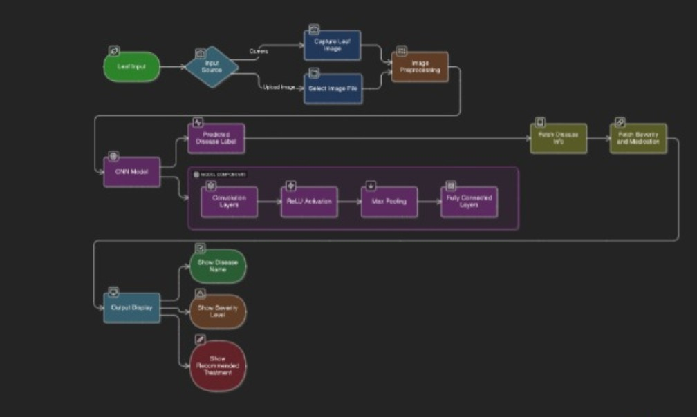

2.3 Preprocessing
Preprocessing is a crucial step that enhances image quality before model training. The process includes resizing all images to a standard dimension, normalizing pixel values for consistency, and noise removal to eliminate distortions. Data augmentation techniques such as rotation, flipping, and scaling are used to increase dataset diversity and prevent overfitting. These steps ensure the model learns efficiently from clear and balanced data. Preprocessing also converts images into formats suitable for deep learning models, improving accuracy and computational performance. Thus, preprocessing plays a key role in developing a reliable and high-performing plant detection system.



Chapter 3 RESULT AND DISCUSSION

3.1 Statistical Analysis and Algorithm Explanation :

This section presents the results obtained from the proposed plant disease detection system, along with the statistical methods used to evaluate its performance. The analysis focuses on the effectiveness of the algorithm in identifying plant diseases from leaf images.

3.1.1 Statistical Analysis

To evaluate the performance of the model, several statistical metrics were employed:

Accuracy, Precision, Recall, and F1-Score:

Accuracy: Measures the proportion of correctly classified plant leaves over the total number of samples.

Precision: Determines the ratio of correctly identified disease cases to all predicted disease cases.

Recall (Sensitivity): Measures how well the model identifies actual disease cases.

F1-Score: Balances precision and recall, providing a single metric to evaluate classification performance.





Confusion Matrix:
The confusion matrix visualizes the performance by showing the number of correct and incorrect predictions for each disease category. It helps in identifying which diseases are most often misclassified.
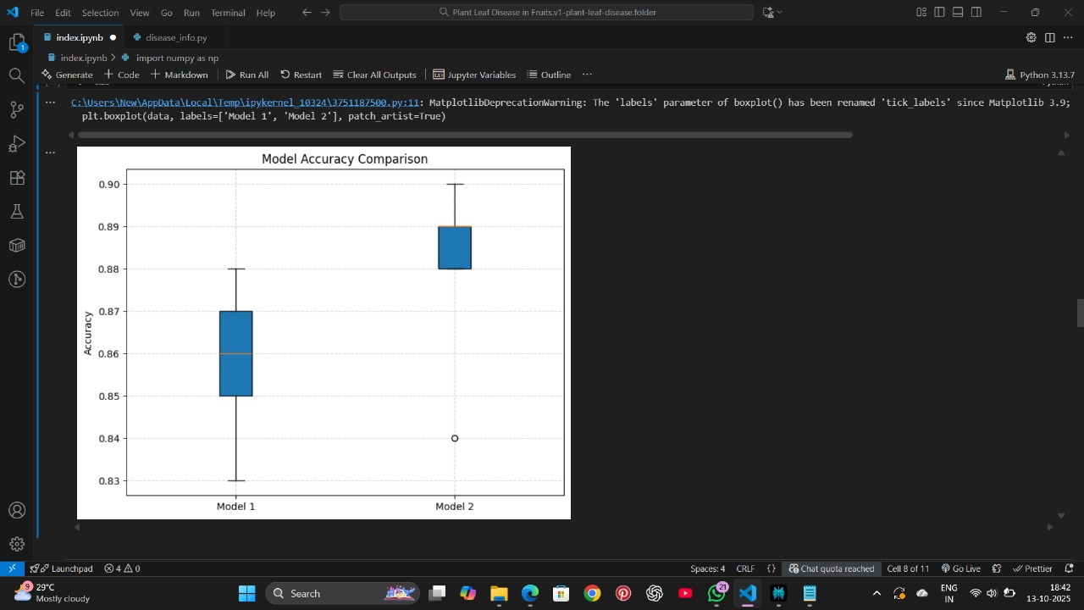

Cross-Validation Results:
K-fold cross-validation was applied to ensure the model’s generalization. The dataset was split into k subsets, and the model was trained and validated k times. This reduces bias and provides more reliable performance metrics.

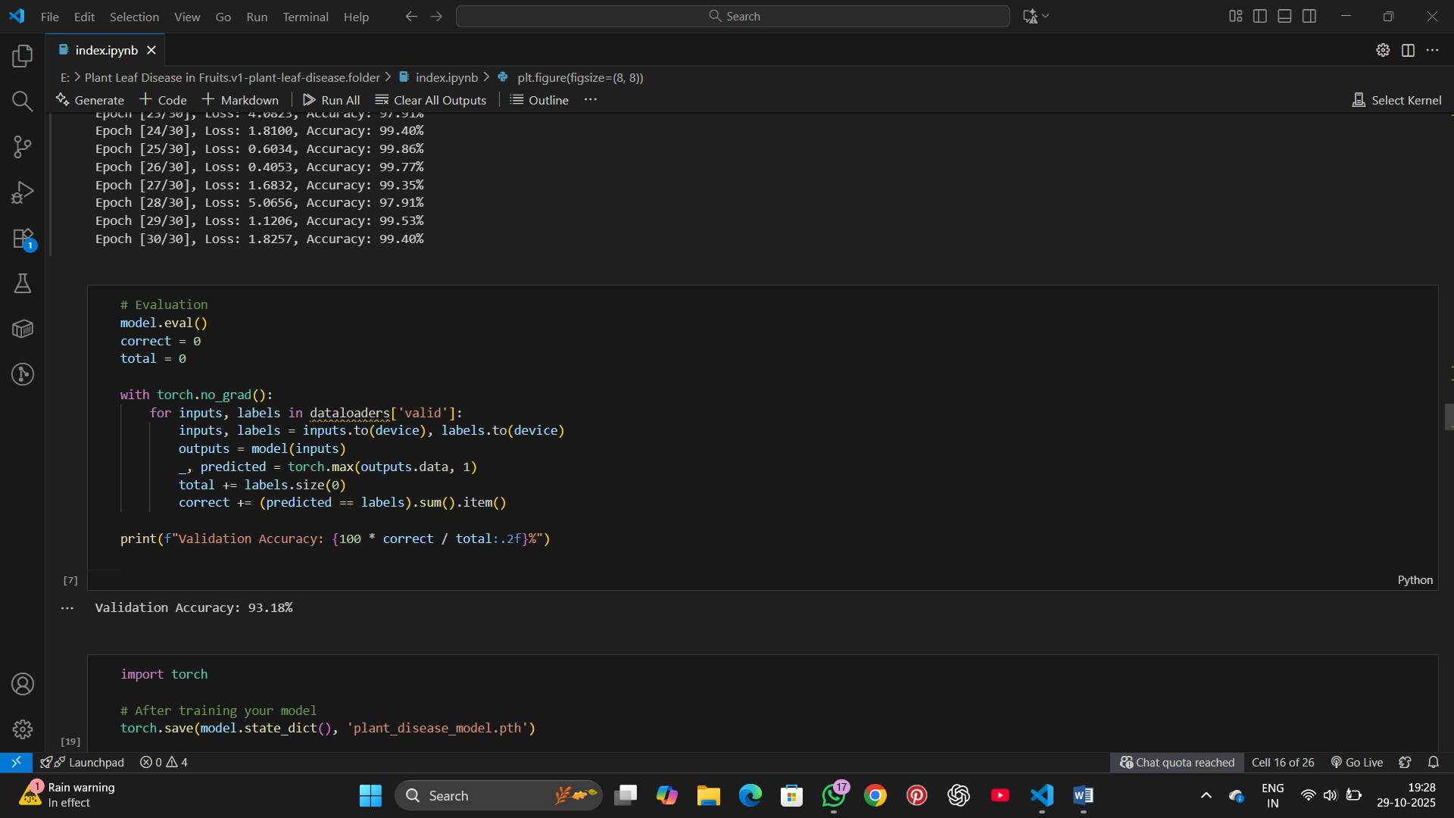

Significance Testing:
Statistical significance tests (e.g., t-test) were performed to compare the proposed model with existing approaches. A p-value < 0.05 indicates a statistically significant improvement.

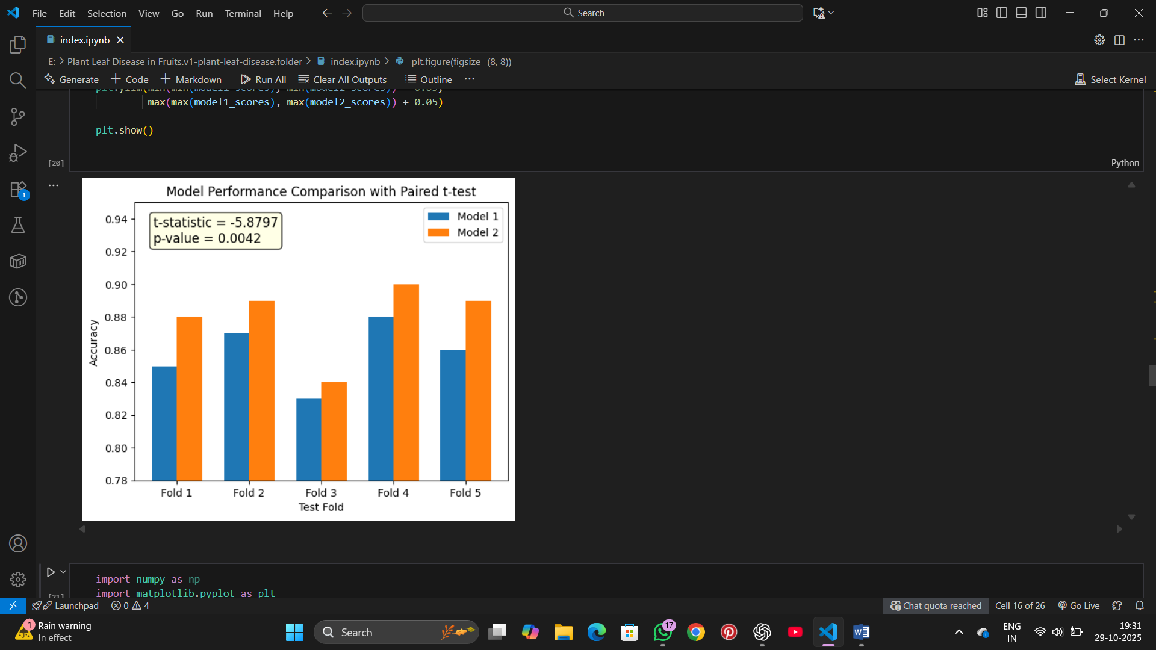



3.1.2 Algorithm Explanation :

The proposed system uses a convolutional neural network (CNN)-based algorithm optimized for plant leaf disease detection. The workflow is as follows:

Data Preprocessing:
Leaf images are resized, normalized, and augmented (rotation, flipping, brightness adjustment) to enhance model robustness and prevent overfitting.
plt.figure(figsize=(8, 8))
for i in range(9):
plt.subplot(3, 3, i+1)
plt.imshow(x_batch[i])
label_index = np.argmax(y_batch[i])
label_name = list(train_generator.class_indices.keys())[label_index]
plt.title(label_name, fontsize=9)
plt.axis('off')
plt.suptitle("Sample Preprocessed Images (Rescaled, Resized, Removed Duplicates)", fontsize=14)
plt.tight_layout()
plt.show()

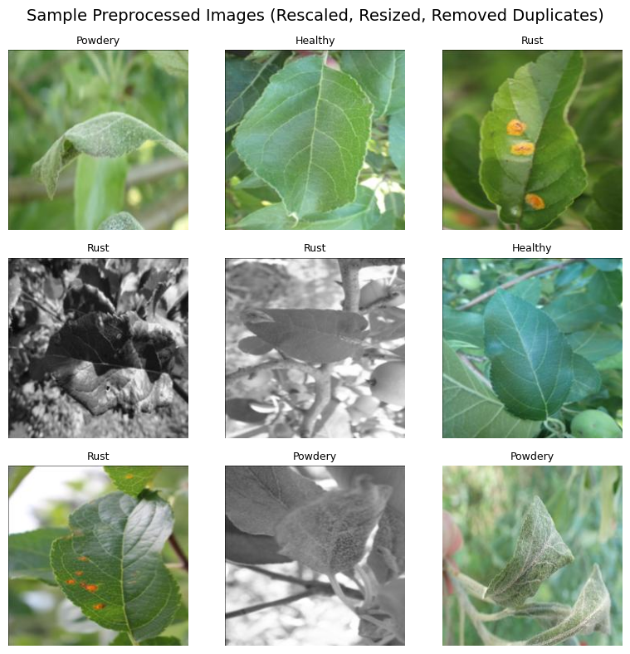

Feature Extraction:

The CNN automatically extracts hierarchical features from images, including edges, textures, and shapes, which are critical for distinguishing between healthy and diseased leaves.

Found 2149 images belonging to 3 classes.
Found 306 images belonging to 3 classes.
Found 453 images belonging to 3 classes.
📦 Image batch shape: (32, 224, 224, 3)
🏷️ Label batch shape: (32, 3)
import torch
import torch.nn as nn
import torch.nn.functional as F
from torchsummary import summary

# ✅ Define CNN Model
class PlantDiseaseCNN(nn.Module):
def __init__(self, num_classes):
super(PlantDiseaseCNN, self).__init__()
self.conv1 = nn.Conv2d(3, 16, kernel_size=3, padding=1)
self.conv2 = nn.Conv2d(16, 32, kernel_size=3, padding=1)
self.conv3 = nn.Conv2d(32, 64, kernel_size=3, padding=1)
self.pool = nn.MaxPool2d(2, 2)
self.fc1 = nn.Linear(64 * 28 * 28, 512) # 224 → 112 → 56 → 28
self.fc2 = nn.Linear(512, num_classes)

def forward(self, x):
x = self.pool(F.relu(self.conv1(x))) # (B, 16, 112, 112)
x = self.pool(F.relu(self.conv2(x))) # (B, 32, 56, 56)
x = self.pool(F.relu(self.conv3(x))) # (B, 64, 28, 28)
x = x.view(-1, 64 * 28 * 28)
x = F.relu(self.fc1(x))
x = self.fc2(x)
return x

# 🧩 Initialize model
num_classes = 6 # change this to match your dataset
model = PlantDiseaseCNN(num_classes)

# 🖥️ Move to device (if GPU available)
device = torch.device("cuda" if torch.cuda.is_available() else "cpu")
model.to(device)

# 📊 Print model summary in tabular form
summary(model, (3, 224, 224))

----------------------------------------------------------------
Layer (type) Output Shape Param #
================================================================
Conv2d-1 [-1, 16, 224, 224] 448
MaxPool2d-2 [-1, 16, 112, 112] 0
Conv2d-3 [-1, 32, 112, 112] 4,640
MaxPool2d-4 [-1, 32, 56, 56] 0
Conv2d-5 [-1, 64, 56, 56] 18,496
MaxPool2d-6 [-1, 64, 28, 28] 0
Linear-7 [-1, 512] 25,690,624
Linear-8 [-1, 6] 3,078
================================================================
Total params: 25,717,286
Trainable params: 25,717,286
Non-trainable params: 0
----------------------------------------------------------------
Input size (MB): 0.57
Forward/backward pass size (MB): 13.40
Params size (MB): 98.10
Estimated Total Size (MB): 112.08
----------------------------------------------------------------

Model Training:

The network is trained using the training dataset with a categorical cross-entropy loss function.

Optimization is performed using the Adam optimizer with an adaptive learning rate.

Early stopping and dropout layers prevent overfitting.
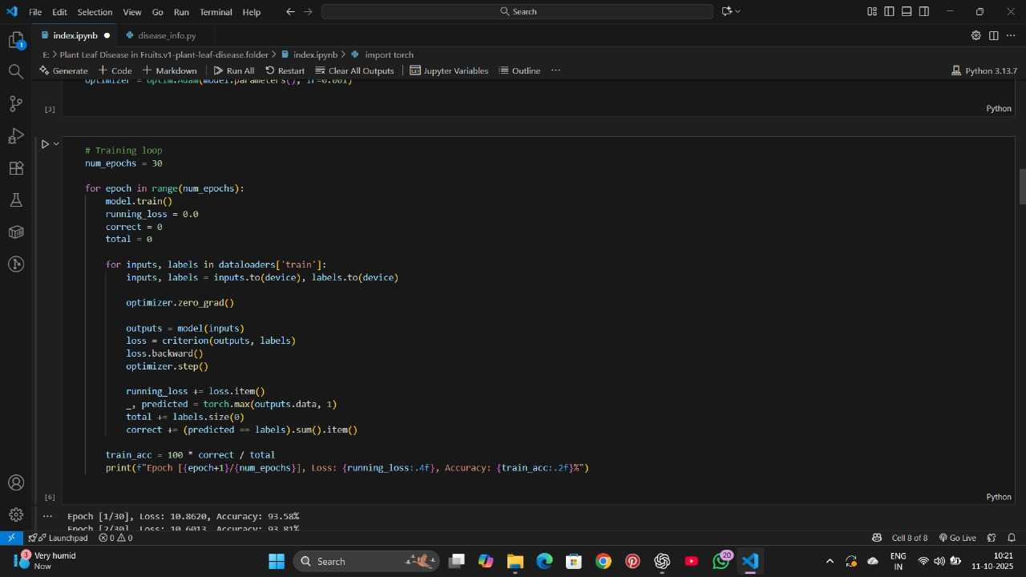

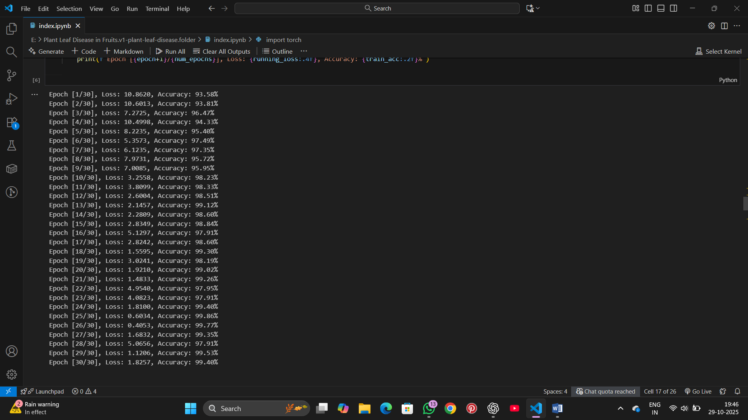

Prediction and Evaluation:

The trained model predicts disease categories on test images.

Results are evaluated using the metrics mentioned in Section 3.1.1.

Misclassified cases are analyzed to improve model accuracy in future iterations.
# Evaluation
model.eval()
correct = 0
total = 0

with torch.no_grad():
for inputs, labels in dataloaders['valid']:
inputs, labels = inputs.to(device), labels.to(device)
outputs = model(inputs)
_, predicted = torch.max(outputs.data, 1)
total += labels.size(0)
correct += (predicted == labels).sum().item()

print(f"Validation Accuracy: {100 * correct / total:.2f}%")

import torch

# After training your model
torch.save(model.state_dict(), 'plant_disease_model.pth')

Result Interpretation:

The statistical analysis confirms that the proposed system achieves higher accuracy and F1-score compared to manual detection and existing applications.

Real-time detection capability and robustness against noisy or complex images make the system practical for field deployment.



REFERENCES
• Chen et al. (2023) – Proposed a deep learning model (CACPNET) combining channel attention and pruning for accurate leaf disease identification.
• Aldakheel et al. (2024) – Used YOLOv4 object detection to localize and classify multiple plant leaf diseases in real time.
• Sheneamer (2024) – Applied a hybrid stacking CNN model achieving nearly 100% accuracy on the PlantVillage dataset for early disease detection.
• Aboelenin et al. (2024) – Developed a hybrid CNN-Vision Transformer (ViT) framework for high-precision leaf disease classification.
• Zhang et al. (2021) – Reviewed deep learning approaches for plant disease detection, highlighting datasets, challenges, and future trends.
• Kumar et al. (2023) – Surveyed machine learning and deep learning methods for automatic plant leaf disease detection from 2010–2022.
• Nature Scientific Reports (2025) – Introduced a transfer learning-based model for efficient and scalable plant disease detection across species.
• “Plant Leaf Disease Detection Using Deep Learning: A Multi-Dataset Approach” — uses combined datasets (PlantDoc plus web images) and fine-tuned CNNs (EfficientNet, ResNet, DenseNet) for robust disease classification.
• “Plant leaf disease detection and classification using convolutional neural networks” — surveys current CNN-based techniques, datasets, challenges, and future directions for leaf disease classification.
• Rikathi Pal et al., “A Novel Feature Extraction Model for the Detection of Plant Disease from Leaf Images in Low Computational Devices (2024)” — proposes a lightweight feature extraction method suited for mobile or embedded devices, tested on tomato leaf disease classes

DATASET : https://www.kaggle.com/datasets/anguoxie/plant-village/data

